|  |  |
| --- | --- |
| **Name** | Muhammad Asad |
| **Reg. No** | 2019-EE-383 |
| **Marks / Grade** |  |

# EXPERIMENT NO. 3

**RESISTOR COMBINATIONS – SERIES AND PARALLEL**

## Objectives:

1. To learn how to connect the resistors in series and parallel on breadboard.
2. To measure the equivalent resistance of series and parallel combination of resistors using digital multi-meter (DMM) and compare with its theoretical value.
3. To verify that same amount of current flows through each series circuit element.
4. To verify that equal voltage appears across each parallel circuit element.

## Apparatus:

Resistors, DMM,

Breadboard,

DC power supply, Connecting wires.

**PART 1: RESISTORS IN SERIES**

**Theory:**

The circuit in which the current remains the same and the voltage is different across each resistor is called a series circuit, as shown in Figure 3.1. In a series circuit the total resistance is the sum of individual resistance values. If *k* number of

resistors is connected in series then the equivalent resistance *Req* is given by,

*Req* = *R*1 + *R*2 + ...+ *Rk* (3.1)

(3.2)

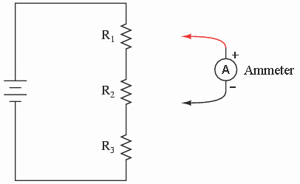

**Figure 3.1: Resistors in series**

## Procedure Exercise # 1:

**Safety Precautions**

* Look at each exercise carefully before connecting the circuits.
* Make sure all power is off before connecting or disconnecting components.
* Ask your instructor to check the circuit before turning on the power.
* When measuring voltage or current, make sure the DMM is correctly set for what you need to measure.

1. Take any three resistors of your choice. Resistance values are marked onto the body of the resistor using a series of colored bands. Find their individual resistance values through color code identification [Lab Experiment 2]; and record these in Table 3.1.
2. Connect the three resistors in series as shown in Figure 3.2.

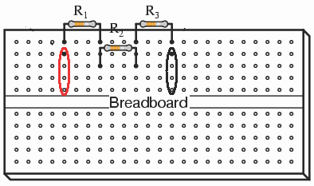

**Figure 3.2: Resistors connected in series on the breadboard**

1. Calculate the value of equivalent series resistance *Req* and record the value in Table 3.1.
2. Measure the equivalent resistance of the circuit on breadboard using the Digital Multi-meter (DMM) being set for resistance measurement; and record the value in Table 3.1. Do the measured and calculated equivalent resistance values agree?
3. Apply 12V across the terminals of the series combination of three resistors on breadboard. The terminals are circled and shown in Figure 3.2.
4. Use Ohm’s law to calculate the value of current *iT* flowing in the circuit. Record this value in Table 3.1.
5. Use DMM being set as ammeter to measure the value of total current *iT*

flowing through the circuit as shown in Figure 3.3. Record the value in Table

3.1. Do the measured and calculated current values agree?

1. Connect the ammeter in series with the first resistor *R1*. The value would give the current *I1* flowing through *R1*. Record the value of current in Table 3.1. Similarly, connect the ammeter in series with the remaining two resistors *R2* and *R3*; and record the *I2* and *I3* current values in Table 3.1. All these values should be same, which shows that when connected in series, the resistors

have same amount of current flowing through them. Comment on the results.

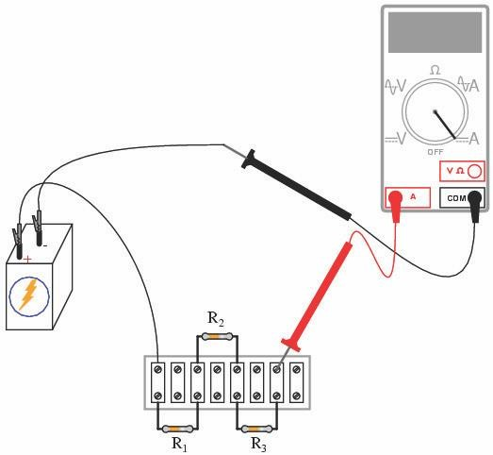

**Figure 3.3: Ammeter connected to measure the total current flowing in the circuit**

|  |  |  |  |  |
| --- | --- | --- | --- | --- |
| ***R1***  ***calculated*** | ***R2***  ***calculated*** | ***R3***  ***calculated*** | ***Req calculated*** | ***Req measured*** |
|  |  |  |  |  |
| ***IT***  ***calculated*** | ***IT***  ***measured*** | ***V1***  ***measured*** | ***V2***  ***measured*** | ***V3***  ***measured*** |
|  |  |  |  |  |

**Table 3.1: Resistors in Series**

### PART 2: RESISTORS IN PARALLEL

**Theory:**

In a parallel circuit voltage across all the resistors remains the same and the supply current or total current is the sum of the individual currents in different parallel paths. The sum of the reciprocal of parallel resistances connected in the circuit is equal to the reciprocal of the equivalent resistance connected in the circuit. If *k* number of resistors is connected in parallel then the equivalent resistance *Req* is

given by,

1 1 1

= +

*Req R*1 *R*2

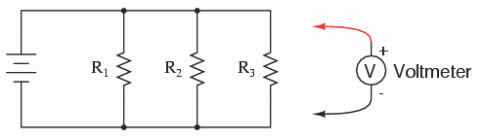+...+ 1

*Rk*

(3.3)

**Figure 3.4: Resistors in parallel**